Visual Studio 2010 Installation Tutorial
07/21/11: U. Pandey

What is Visual Studio?

“Microsoft Visual Studio is a powerful IDE (Integrated Development Environment) that ensures quality code throughout the entire application lifecycle, from design to deployment. Whether you’re developing applications for SharePoint, the web, Windows, Windows Phone, and beyond, Visual Studio is your ultimate all-in-one solution.”
from http://www.microsoft.com/visualstudio/en-us

Getting a copy of the Professional Edition

If you received a DVD with Visual Studio 2010, skip this and the following few sections and go to installation.

Visual Studio is a rather expensive professional software but students can get their hands on a copy of the professional edition by participating in dreamspark. You'll get an iso image of the DVD containing the software. You can think of that as a virtual copy of the DVD. You'll need an image mounting software in order to install the program using the iso image. I will be using Daemon Tools (Google it or visit http://www.daemon-tools.cc/eng/downloads and download the lite version for free) to mount the image file. You can skip ahead to the section describing usage of Daemon Tools once you have the image file containing Visual Studio 2010 Professional Edition.

For this and almost all of my tutorials, I will be using Mozilla Firefox as the browser.

Downloading the iso image file

To get yourself a copy of Visual Studio 2010 Professional Edition, create an account in http://www.dreamspark.com. Dreamspark is an initiative by Microsoft to provide students with access to professional developer tools. You'll need a windows Live ID to sign in. You can sign up for one at http://www.live.com if you don't have one. You'll also need to verify that you are indeed a student by activating your account through your college e-mail address before you can download the products listed in the website.

The product page for Visual Studio 2010 is located here: https://www.dreamspark.com/Products/Product.aspx?ProductId=25&lc=1033 . Go to that link or find Visual Studio 2010 Professional edition from the listed software.

The website looks like this:
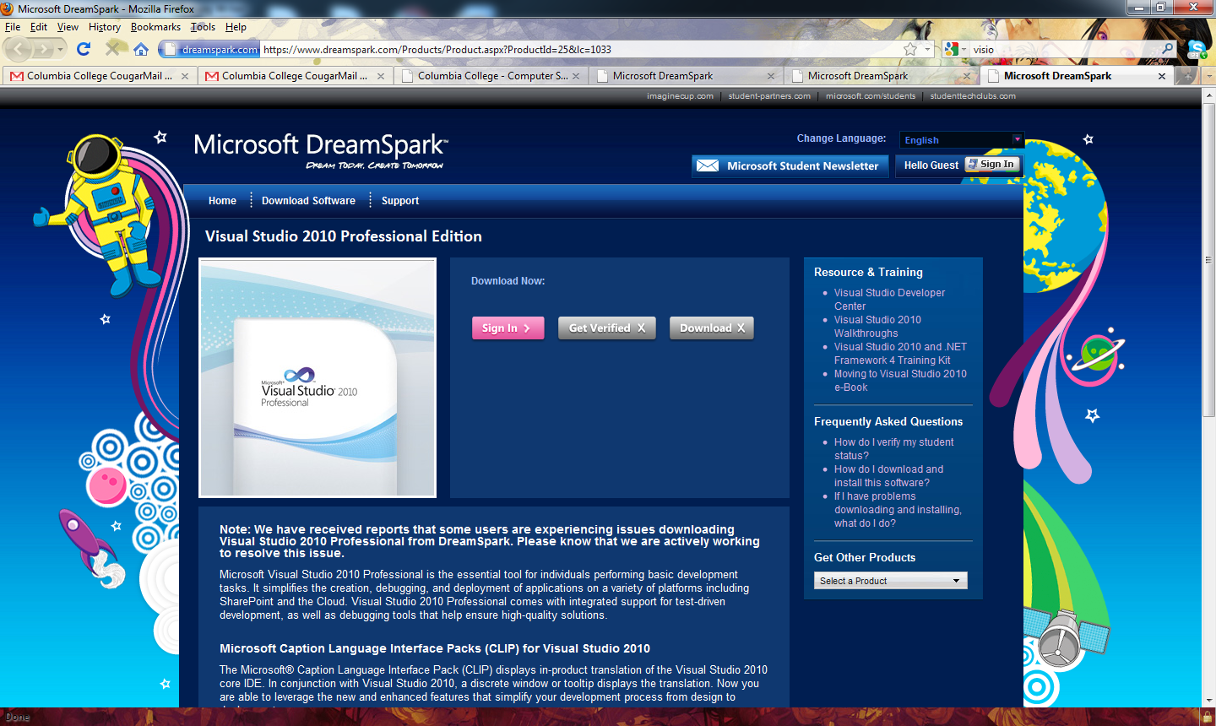

Go ahead and sign in using the button under Download Now.
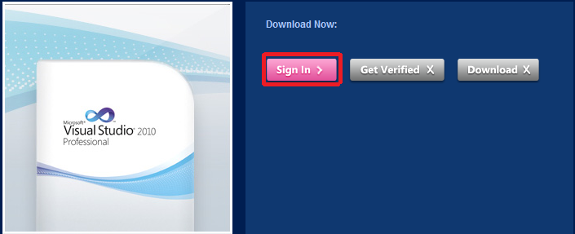

It takes you to the windows live page where you can sign in using your live account. Once signed in, your “Get Verified” button should be enabled. Click it.
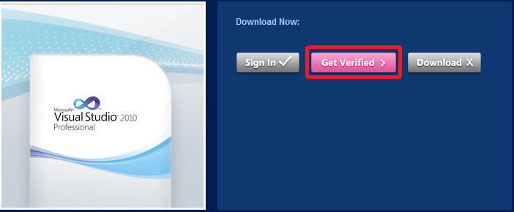

Answer the Questions in the page that comes up. Choose to get verified through the school if its your first time using the site. If you have used the site before, use the activation code you received to verify your account. Hit continue to continue.
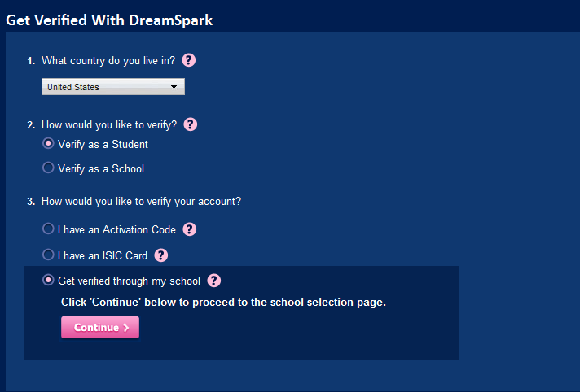
In the next page, you'll need to select Columbia College as your school. Hit continue to Continue after selecting Columbia College.
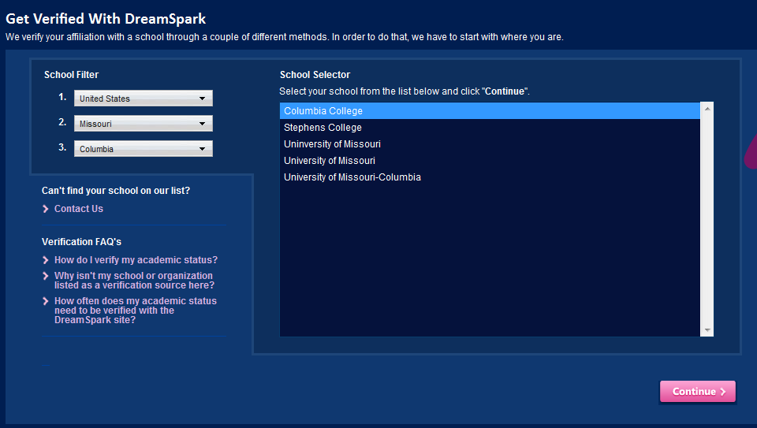

Fill in your information on the next page. Make sure you provide your xyz@cougars.ccis.edu e-mail address. Hit Verify to continue.
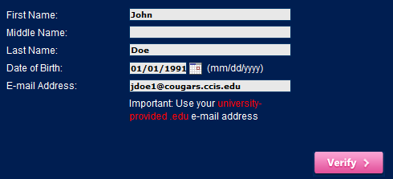

You should receive a confirmation page like this one:
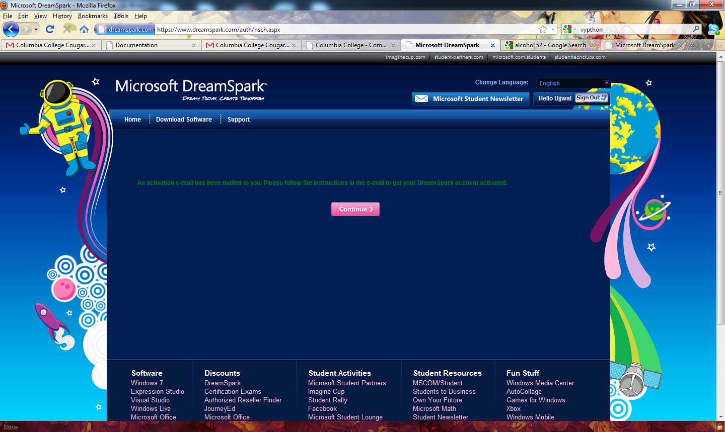

You will then receive an activation email from dreamspark with information as to how to activate. The email will contain a 25 characters long Access Key. Enter the access key at the activation URL: https://www.dreamspark.com/Activate. You'll need to sign in with your live id if you chose to activate at some other time and get signed out.

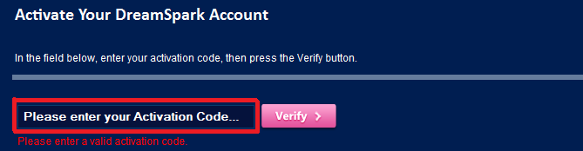

Enter your code in the field and hit verify to continue. You should receive a confirmation page like this one:

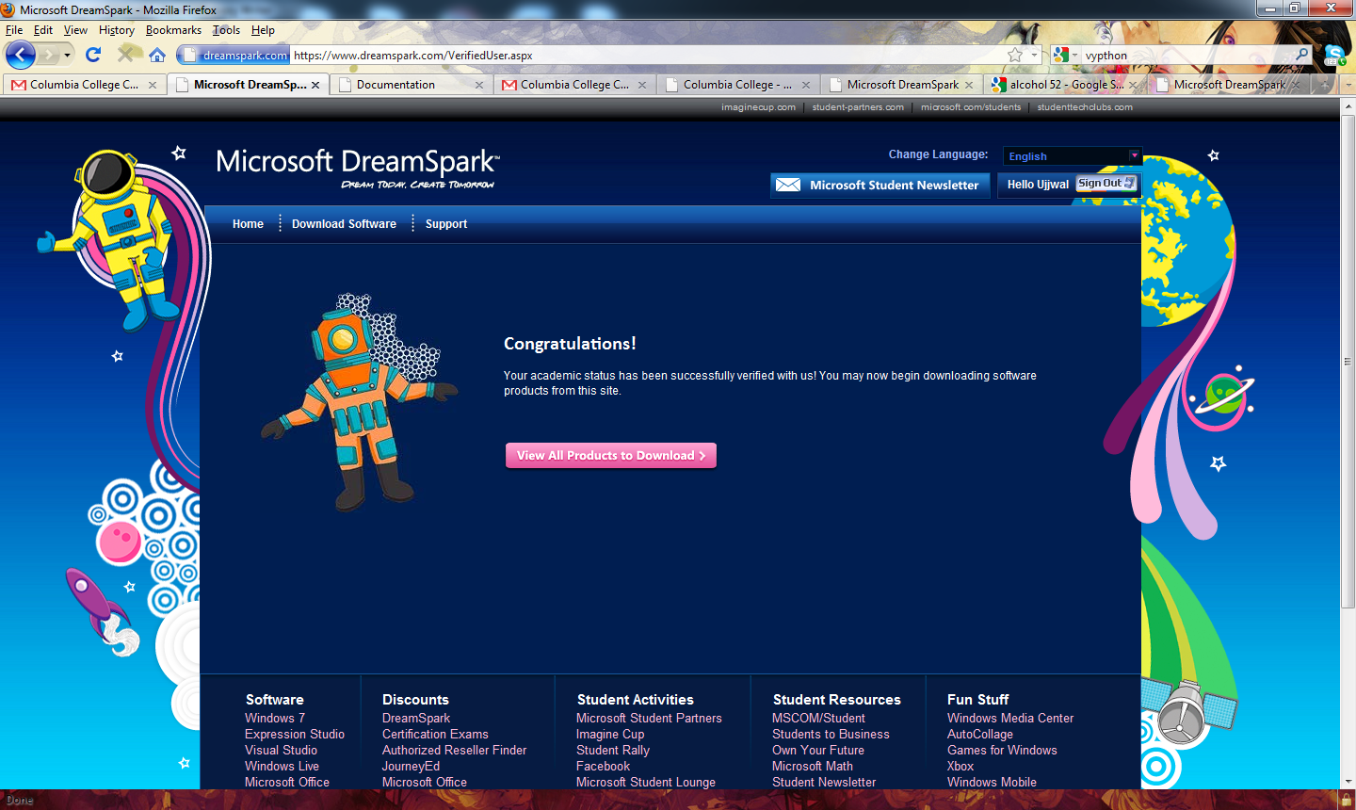

Click on “View All Products to Download.” Since we went through the verification process through Visual Studio 2010 page, it should take you back there. If you activated your account in a later session, you'll need to find Visual Studio 2010 in the products page and click the link. As you can see, its right at the start of the list.

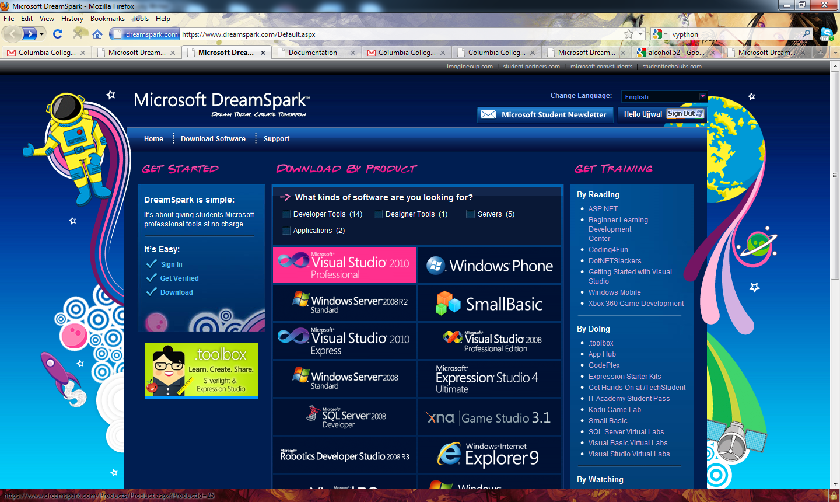

In the download page, choose your preferred method of download and click on download button. I don't like installing unnecessary stuff so I download through the web but if you have slow internet, using the download manager can be a wise option.
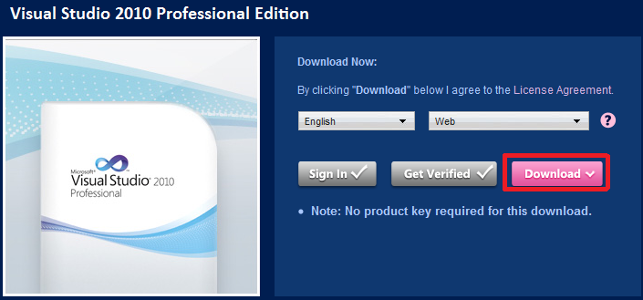

Once you click on download, a dialog box should open up asking you if you want to run or save the file. Choose to save the file. You can choose the location to save the file onto.
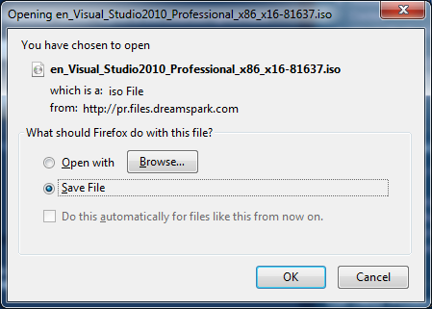

Once you are done downloading, you should see an iso file at the location you saved the download as.
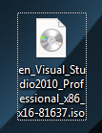

Getting Daemon Tools

Important note: If you already have daemon tools or some other software (like alcohol 120%) to mount iso files, skip this step.

To get Daemon Tools, either Google it and download then install a version or go to http://www.daemon-tools.cc/eng/downloads and download the Lite version for free.
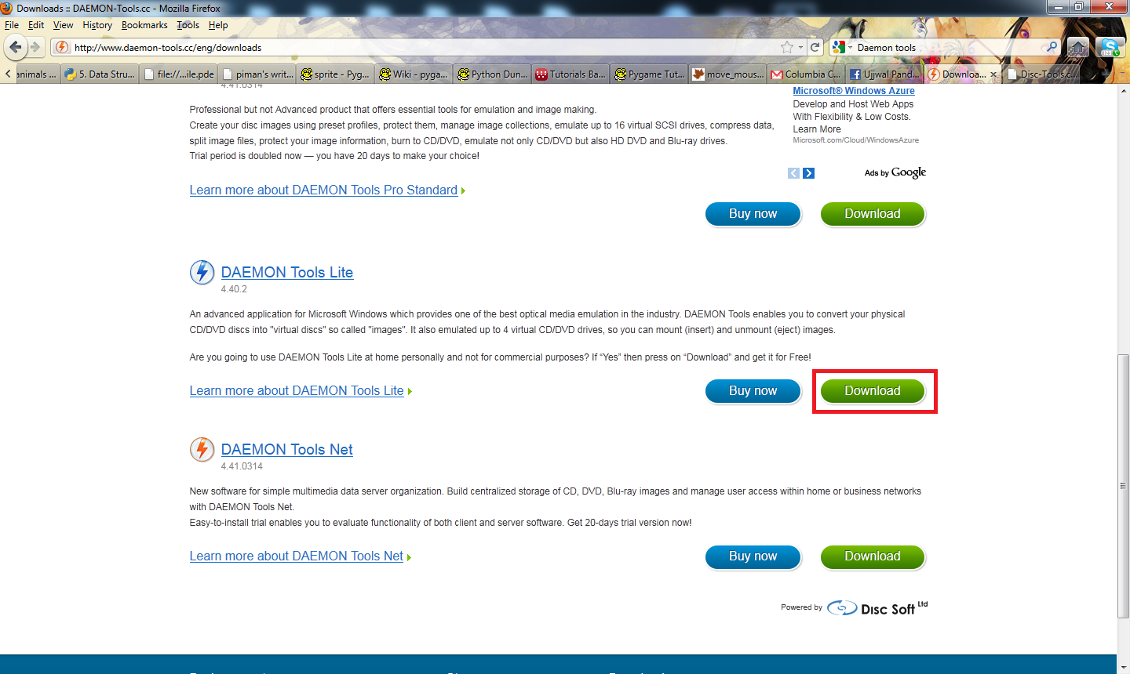
You should get the following screen. Click on download again.
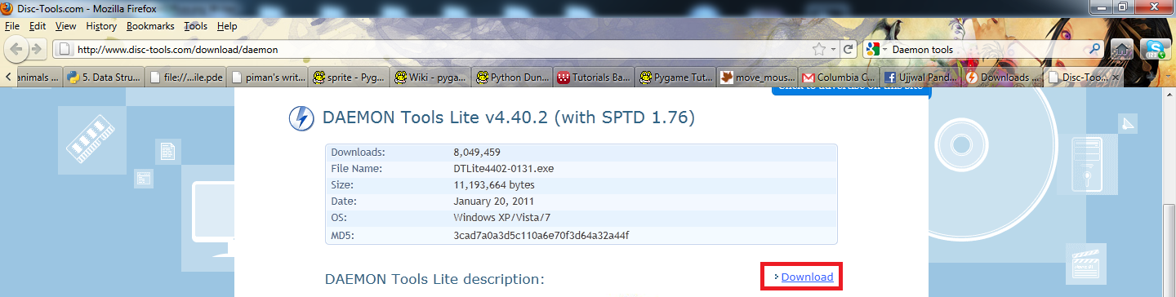
You will get a dialogue box asking you to save the file. Choose to do so
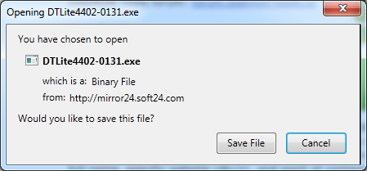
Next, run the file by visiting the folder you downloaded it onto and double clicking it. You will be asked to provide administrator access. Choose to do so.

You should see the following dialog box.
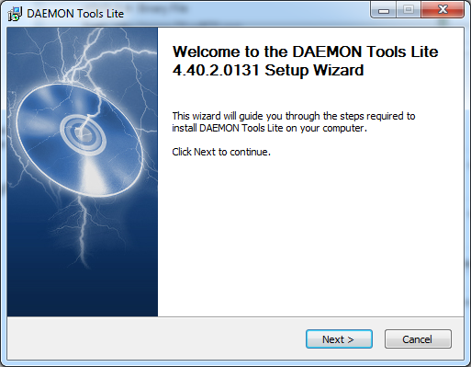
Keep hitting next. It will install the software then ask for a reboot. Choose to do so.

Mounting the iso file

Once you have successfully installed Daemon Tools and downloaded the “en_Visual_Studio2010_Professional_x86_x16-81637.iso” file, double click on the Dameon Tools icon in Desktop to run it.
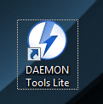

The daemon tools icon will show up on your task bar. Right click it and select “Mount'n'Drive Manager”.

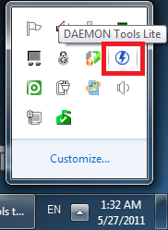
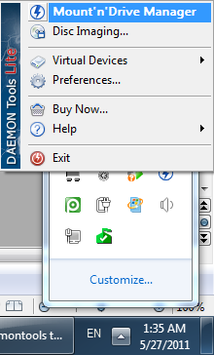
You should see the following screen.
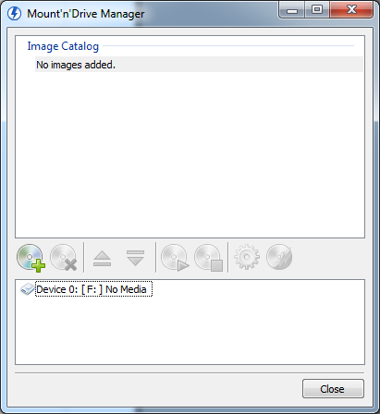
Right click the Device with No media mounted that is listed (The letter can differ depending on how many drives you have) then click on mount.
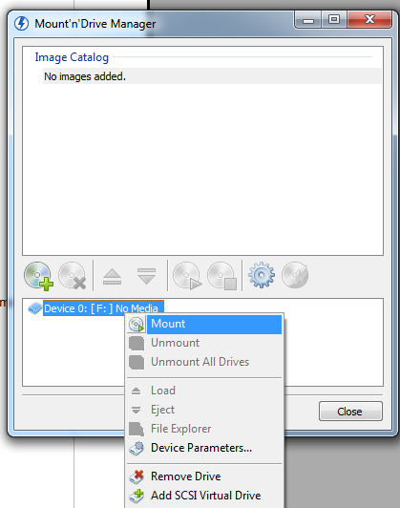
You should get a file browser. Locate the “en_Visual_Studio2010_Professional_x86_x16-81637.iso” file and then click on open.
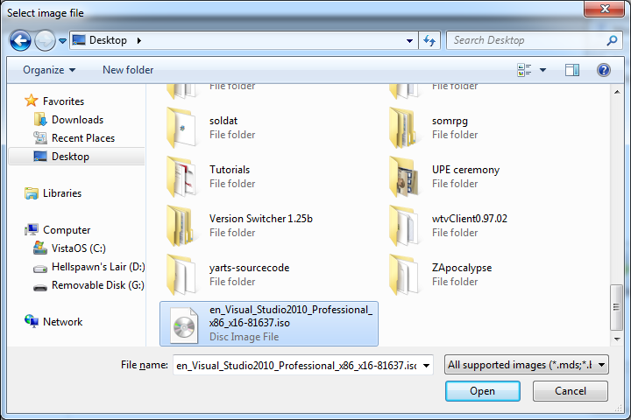

INSTALLING VISUAL STUDIO 2010

Now load your Computer and go to the drive that just got mounted. Or, if you received a DVD, locate it. Then open it.
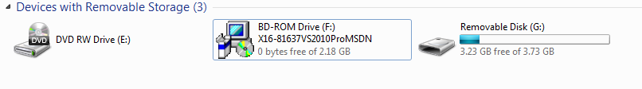
Run setup.exe. You will need administrator privileges to run it.

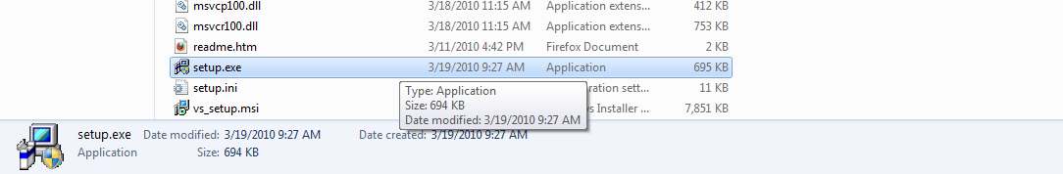
Click on install Microsoft Visual Studio 2010 on the screen that shows up.

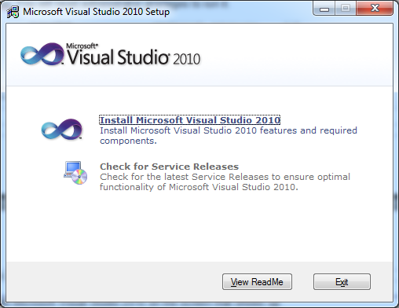

Wait while it loads up then click on next.

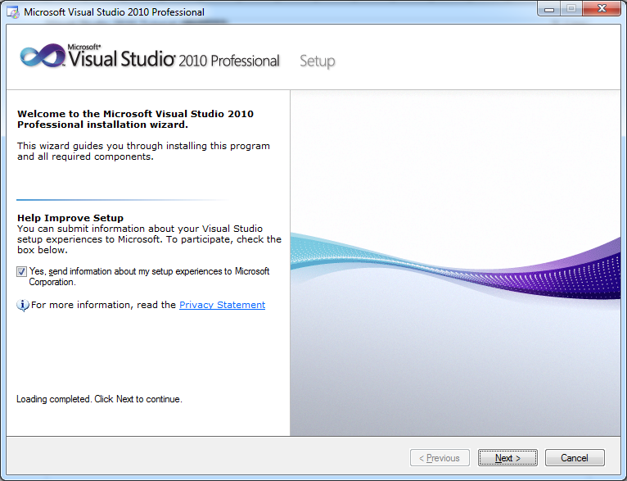
Accept the terms and click on next.
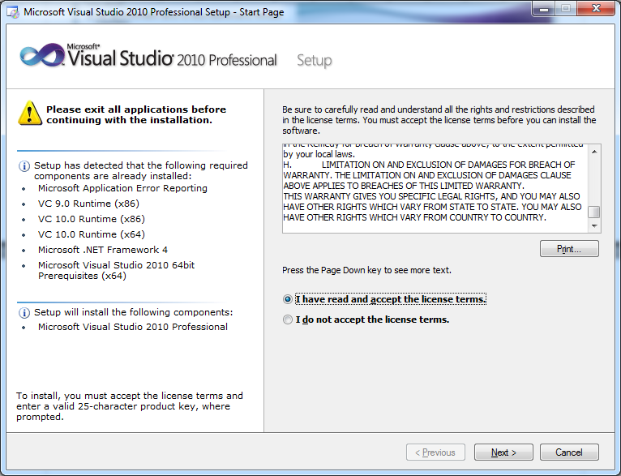
Choose Full and click on Install. You can change the install location if you want.

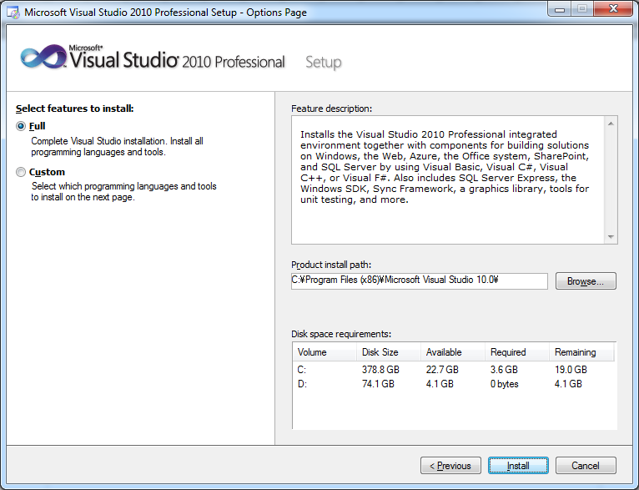

Wait for it to finish installing then click on finish.

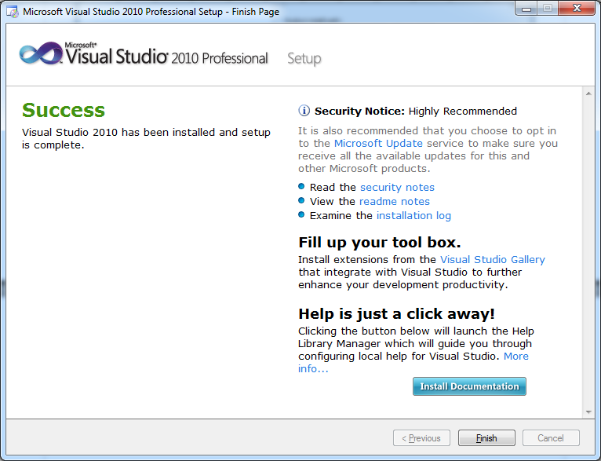
It will load the setup GUI again, you can exit out of it.

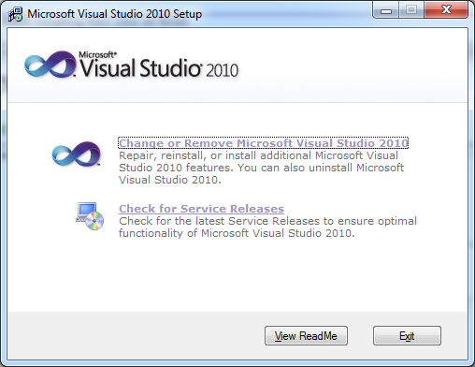
To load Visual Studio 2010, click on start button then All Programs.

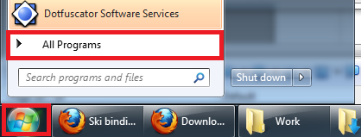
Then select Microsoft Visual Studio 2010 and click on Microsoft Visual Studio 2010.

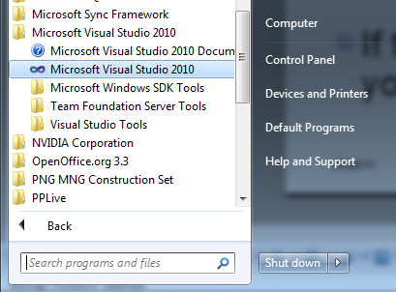

You should see the following Screen.

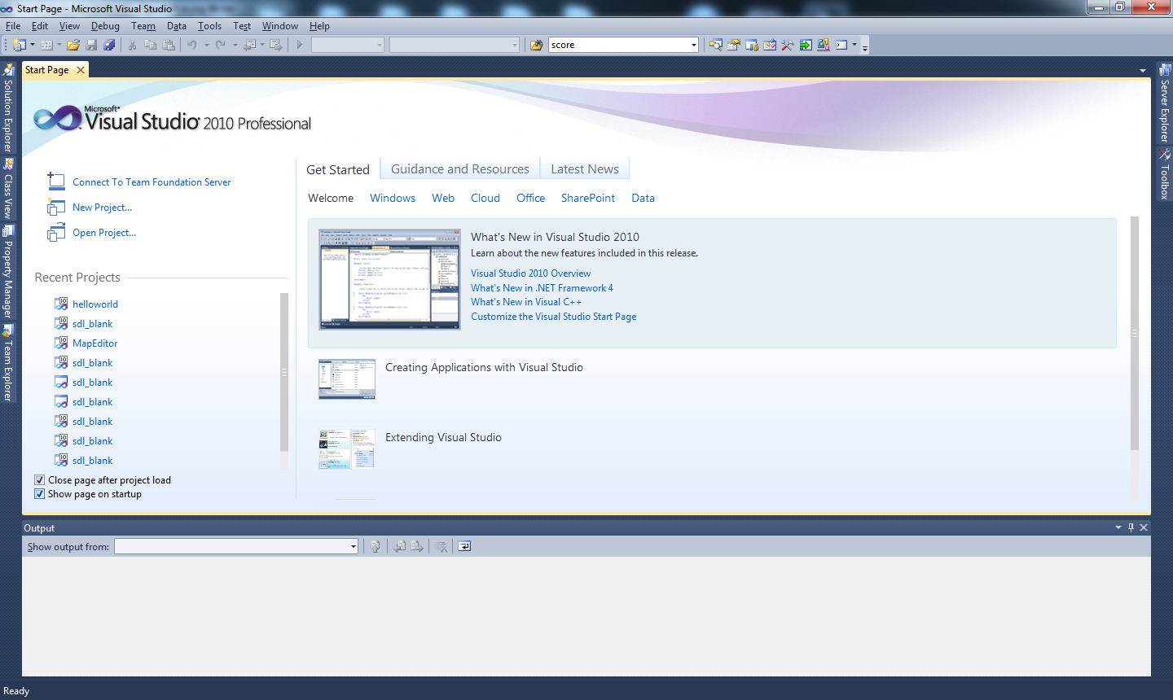
Congratulations! That's all for Visual Studio 2010 Installation. Read up on how to use Visual Studio 2010 through Google. There is also a tutorial to teach you the very basics.
Important Note

You should know that all Columbia College policies apply to our department servers. In particular you should only use the server for work related to your classes. If in doubt, you should always consult with the instructor. Violation of policies will result in suspension of your account for a period of time determined by the Computer Science faculty.

